840/2
COMPUTER STUDIES
PRACTICAL
PAPER 2
AUG 2023
2¹/₂ HOURS


NATIONAL EDUCATION RESEARCH & EXAMINATIONS BUREAU
UCE NEREB NATIONAL MOCKS 2023
COMPUTER STUDIES
PAPER 2
(PRACTICAL)
2 HOURS: 30 MINUTES

INSTRUCTIONS TO CANDIDATES
- This paper consists of two sections, A and B.
- Answer all questions in section A and two questions in section B
- Each candidate will require a new CD.
- Create a folder on desktop bearing your name and class. Save all your attempted questions in the above folder
- Each candidate must produce a hard copy for each of their work to accompany the CD
- Software help wizards must not be used.

SECTION A (40 MARKS)
This section is compulsory
- a) Typeset the passage below as it appears and save it as your name and index number. (06 marks)

O
once there was a small town; a man was living happily with small family comprising his wife and a son. They had a beautiful house having lush green garden in front and backyard. As his son was growing up, he noticed that the little boy’s behavior was getting changed. His son was developing a very bad temper.

H
e tried to counsel him, but there was no result. The boy used to get angry very frequently and often out of anger he used bad language. His words started hurting others. He scolded kids in school, neighbors and even his friends due to anger. His friends and neighbors started avoiding him, and his parents were getting really worried about him
.
Lesson from Life is …like a cup of coffee
T
he professor continued, “Every one of you wanted the best CUPS. While it is, of course normal for you to want only the best for yourselves, that can also be the source of much of your dissatisfaction, problems and stress and tension in life.”
- Copy the passage to page2 of the document and perform the following changes on the pasted copy. (02 mark)
- . Insert a suitable heading at the top, centre it and give it size 13.(03 marks)
- Change the line spacing of the document to 1.5 line spaces, 5 before and after. (02 marks)
- Increase the font size of all the text except the heading to 13.5. (01 marks)
- Justify the entire document. (01 mark)
- Put an Art page border of your choice. (01 mark)
- Insert a water mark of your names on only page 2 (01 mark)
- Insert page numbers in the top margin starting at 5. (02 marks)
- Save and Print the edited document. (01 mark)
b) Using a spreadsheet application of your choice, key in the following data and save it as your name and personal number. (04 marks)
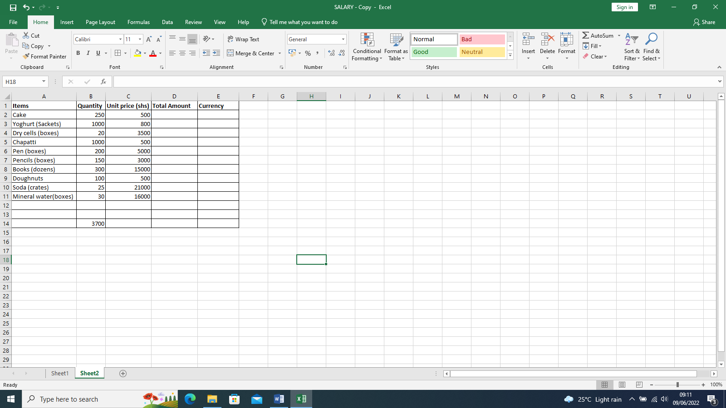
- Determine the Total Amount, given that it is the product of Quantity and Unit price. (03 marks)
- Using the value in cell B14, fill the column for Currency with the conversion values for Total Amount in dollars. (03 marks)
- Create a 3D column chart using the column for Item and Currency.
(04 marks)
- Move the chart to its own new sheet. (02 marks)
- Rename sheet1 as TABLE. (01 mark)
- Insert a footer of your name and class. (02 marks)
- Save and print the work. (01 mark)
SECTION B (60 marks)
Answer any two questions from this section
- You have been chosen in your village to prepare and give a presentation during a campaign to create awareness to your community about increasing school dropouts.
Prepare a five-slide presentation and save it as your name and personal number. (02 marks)
Slide1: Include a suitable title basing on the topic under study, your name in sub-title area and automatically updating date. (03 marks)
Slide2: Use a two column slide indicate cause of school dropouts (03 marks)
Slide3: to include a list of solution to school dropouts in your village (03 marks)
Slide4: Insert the table below indicating the drop numbers between 2018 and 2021. (04 marks)
YEAR | NUMBER OF DROPOUTS
2018 | 345
2019 | 289
2020 | 440
2021 | 380

Slide5: Use the table in slide 4 above to create a graph representing the dropout number. (04 marks)
- Using a slide master Apply a uniform background design that can leave the content readable. (01 marks)
- Use simple and uniform animations and slide transitions. (02 marks)
- Insert suitable pictures on slide 1 and slide 3 (02 marks)
- Apply navigation buttons on all slide (01 mark)
- Apply users notes on page 3 (01 mark)
- Set your presentation to run automatically after 5seconds per slide.
(02 marks)
- Add your name as footer. (01 mark)
- Printing all the slides on one page as handout. (01 mark)

- The Ministry of Health is to carry out mass immunization in Uganda. The Ministry is to conduct a competition for selecting the best site. You have been asked to participate in the competition and provided the following details.
Instructions:
- Using a webpage publishing software design a three paged website saved as Your-Names competitions. (01 marks)
- Page one should page a home page with navigation buttons and links to the other three slides, a welcoming message and a brief introduction (04 marks)
- On Page two include the meaning of immunization. Mention three bulleted reasons for immunizing children below the age of 5 years. Include the six killer diseases that children have to be immunized against. Bullet the diseases. (04 marks)
- Page three: program; on this page, include the program of immunization in Uganda. Uganda is divided into five sections: North, East, West, Central and South. Under these headings, mention two districts from each region to work as a co-rdinating centre. Remember to bullet the districts respectively. (04 marks)

- On page four: Contact us, on this page, write down a list of 10 individuals that have to be contacted for details. Give the details in a table of 10 x 2 in the form of: (04 marks)

Name | Contact
You are free to write the physical address, telephone number and time of contact.
- Add a banner ‘Ministry of Health – Uganda’ that will be shared on the two pages (02 marks)
- Add a marquee, ‘Kick polio out of Uganda’. It should be is a red colour. (02 marks)
- Insert two relevant graphics on each page. (02 marks)
- Add a search facility of other Ministry Links in Uganda. (02 marks)
- Choose a uniform, good background theme for the two pages. (02 marks)
- Add the current time after the marquee on the extreme right with: Time in Kampala: your date goes here. (02 marks)
- Print your website. (01 marks)

- The table below represents a group of students of a certain school.
- Create a database, save it as your name and personal number and use it to manage the above data. (02 marks)
Student no: | Name | Other name | Class | Sex | Date of Birth | Fees | Amount paid | Balance
KPS-001 | Nalwadda | Anisha | 5A | M | 01/09/2000 | 160,000 | 100000
KPS-002 | Haram | Kajubu | 3B | F | 25/05/2001 | 360,000 | 160000
KPS-003 | Ssebi | Hizam | 4B | M | 14/02/2004 | 150,000 | 120000
KPS-004 | Ssegujja | Sharabiabil | 5A | M | 30/07/2002 | 160,000 | 160000
KPS-005 | Nkoyoyo | Eric | 5A | F | 01/09/2000 | 150,000 | 150000
KPS-006 | Basirika | Brendah | 3B | M | 25/05/2001 | 120,000 | 80000
KPS-007 | Nsubuga | Patrick | 3B | M | 14/02/2005 | 500,000 | 250000
KPS-008 | Ssendagire | Joel | 6A | F | 30/07/2002 | 200,000 | 200000
KPS-009 | Mubiru | Emmanual | 3B | M | 01/06/2003 | 120,000 | 100000
KPS-010 | Nankumba | Anishat | 3B | M | 25/03/2005 | 120,000 | 750000
KPS-011 | Nalusiba | Anishat | 4B | M | 14/011/2004 | 200,000 | 150000
KPS-012 | Koryom | John | 6A | F | 30/12/2002 | 300,000 | 300000

- Design a table and set appropriate data-types. Name it students.(04 marks)
- Enter the data above in the table. (04 marks)
- Using the table you have created find the students balance. (02 marks)
- Create a query to display; -
- Students whose names begin with letter S. Save it as S-name query.
(02 marks)
- Female Students who come from “3B”. Save it as 3B Female query
(02 marks)
- A query to calculate the age of the students. (02 marks)
- students with a calculated field for TERM2, given that school fees increase by Shs.50,000. Save it as Term2 query. (04 marks)
- Create form for the table. Call it Students form. (04 marks)
- Create a report for all students, saved as Students report. (02 marks)
- Save and print all the objects. (02 marks)

END

